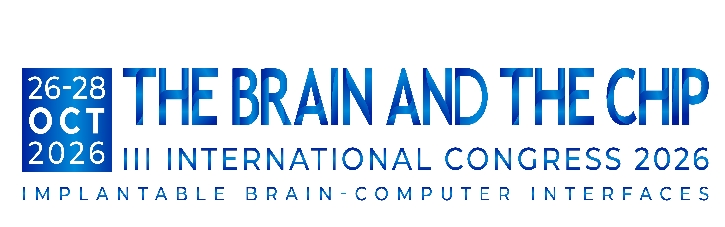
October 26-28, 2026 Abstract Submission Open Date: July 1, 2026 In Person Abstract Submission Deadline: September 6, 2026

Abstract Title:
Last Name: | First Name:
Degree(s): | Title:
Email Address: | Can Email be made public?
Organization:
Street Address:
City and Zip code: | Country:
Office Telephone #: | Cell #:

The Brain and the Chip seeks to showcase the newest research.

Please describe briefly the new or most recent research you plan to present:
Please attach your abstract (PDF or Word) along with this form for submission to: the_brain_and_the_chip@umh.es
Please indicate if the abstract is for  Platform Presentation  Poster Presentation
May your presentation, if accepted for platform presentation, be videotaped for online distribution to attendees?  Yes  No

